**JAGAN INSTITUTE OF MANAGEMENT STUDIES**

**Sector - 5, Rohini, New Delhi**



**(Affiliated to)**

**GURU GOBIND SINGH INDRAPRASTHA UNIVERSITY**

**SECTOR – 16 C, DWARKA, NEW DELHI**



**PRACTICAL FILE**

**COMPUTER GRAPHICS**

**BCA-373**

Submitted to: Ms. Geeta Sharma Submitted By: Aditya Pandey

Professor (IT) Enrolment No.: 04814002021

BCA 3rd Year (Shift - 1)

5th Semester

**Aditya Pandey (04814002021)  
BCA 3rd Year 1st Shift  
Computer Graphics (BCA 373)  
Practical Assignment 1**

**Q1. Working with coordinates:**

1. **WAP to create * symbol.**

#include<stdio.h>   
#include<conio.h>   
#include<graphics.h>

void main() {   
 int i;   
 int gd = DETECT, gm;   
 int x1 = 50, y1 = 50, x2 = 500, y2 = 350;   
 initgraph(&gd, &gm, "C:\\TC\\BGI");   
 line(50, 50, 150, 150);   
 line(50, 150, 150, 50);   
 line(100, 50, 100, 150);   
 line(50, 100, 150, 100);   
 getch();   
 closegraph();   
}

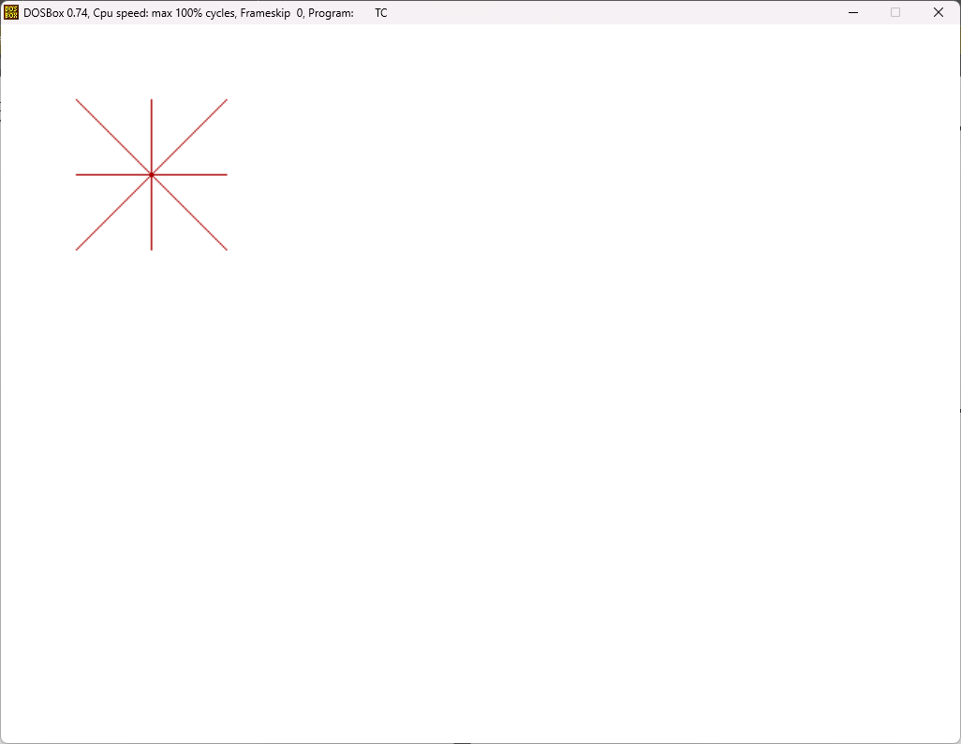

(Aditya Pandey)

1. **WAP to create a square using lines.**

#include<stdio.h>   
#include<conio.h>   
#include<graphics.h>

void main() {   
 int i;   
 int gd = DETECT, gm;   
 int x1 = 50, y1 = 50, x2 = 500, y2 = 350;   
 initgraph(&gd, &gm, "C:\\TC\\BGI");   
 line(100, 100, 200, 100);   
 line(200, 100, 200, 200);   
 line(200, 200, 100, 200);   
 line(100, 200, 100, 100);   
 getch();   
 closegraph();   
}

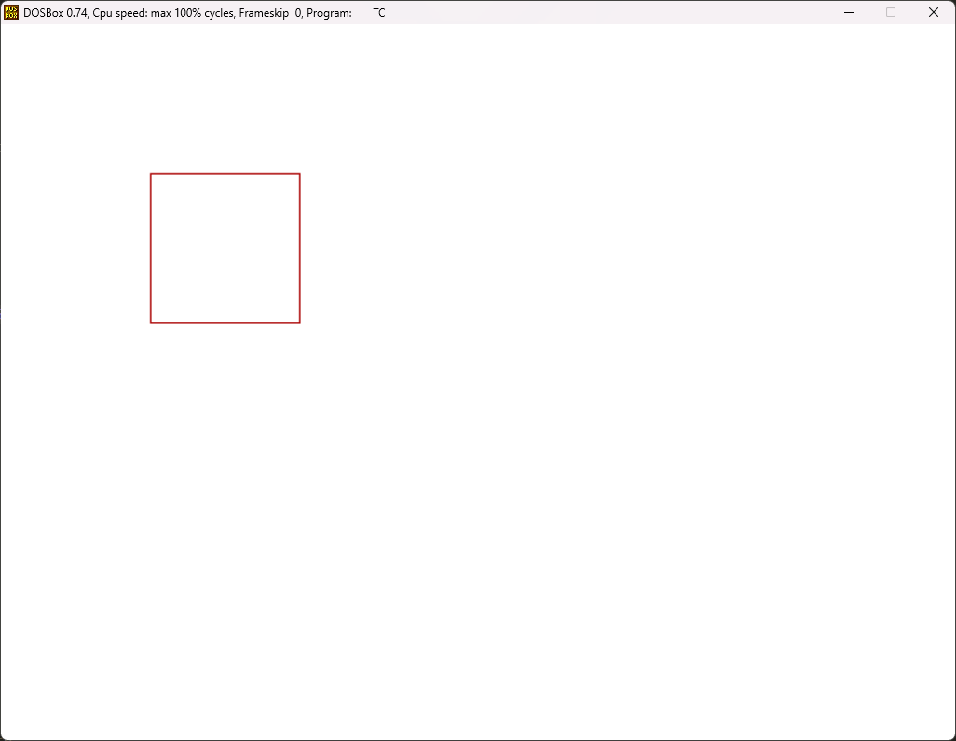

(Aditya Pandey)

1. **WAP to create rectangle inside rectangle.**

#include<stdio.h>   
#include<conio.h>   
#include<graphics.h>

void main() {   
 int i;   
 int gd = DETECT, gm;   
 int x1 = 50, y1 = 50, x2 = 500, y2 = 350;   
 initgraph(&gd, &gm, "C:\\TC\\BGI");   
 for(i=0 ; i<150 ; i+=2) {   
 rectangle(x1, y1, x2, y2);   
 x1+=2; y1+=2; x2-=2; y2-=2;   
 }   
 getch();   
 closegraph();   
}

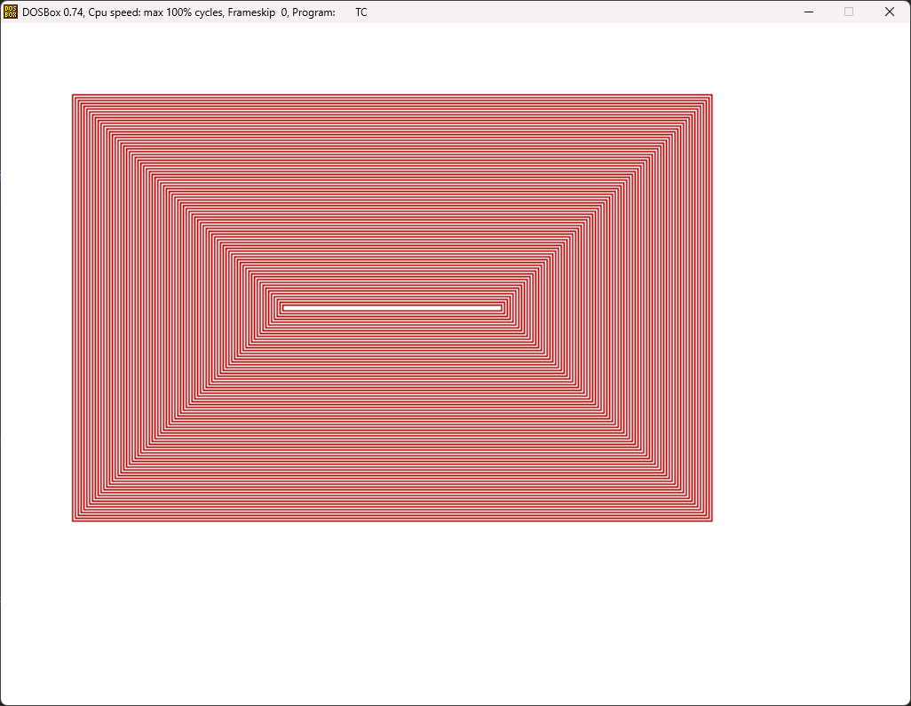

(Aditya Pandey)

1. **WAP to create a smiley.**

#include<stdio.h>   
#include<conio.h>   
#include<graphics.h>

void main() {   
 int i;   
 int gd = DETECT, gm;   
 int x1 = 50, y1 = 50, x2 = 500, y2 = 350;   
 initgraph(&gd, &gm, "C:\\TC\\BGI");   
 circle(250, 250, 200);   
 circle(175, 150, 25);   
 circle(325, 150, 25);   
 line(250, 200, 225, 275);   
 line(225, 275, 250, 275);   
 line(150, 300, 250, 400);   
 line(250, 400, 350, 300);   
 getch();   
 closegraph();   
}

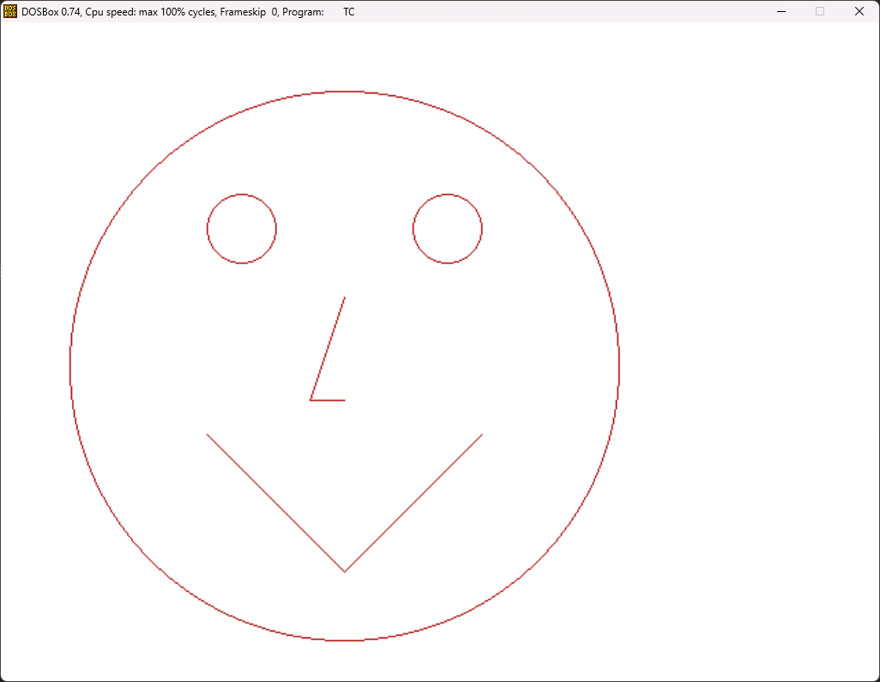

(Aditya Pandey)

**Q2. WAP to scan convert a line using DDA Line Drawing Alogrithm.**

#include<stdio.h>   
#include<conio.h>   
#include<graphics.h>

void main() {   
 int gd = DETECT, gm;   
 float x, y, dx, dy, steps;   
 int x0, x1, y0, y1, i;   
 initgraph(&gd, &gm, "C:\\TC\\BGI");   
 setbkcolor(WHITE);   
 x0 = 100, y0 = 100, x1 = 500, y1 = 200;   
 dx = (float)(x1-x0);   
 dy = (float)(y1-y0);   
 if(dx>=dy) {   
 steps = dx;   
 } else {   
 steps = dy;   
 }   
 dx = dx/steps;   
 dy = dy/steps;   
 x = x0;   
 y = y0;   
 i = 1;   
 while(i<=steps) {   
 putpixel(x, y, RED);   
 x += dx;   
 y += dy;   
 i += 1;   
 }   
 getch();   
 closegraph();   
}

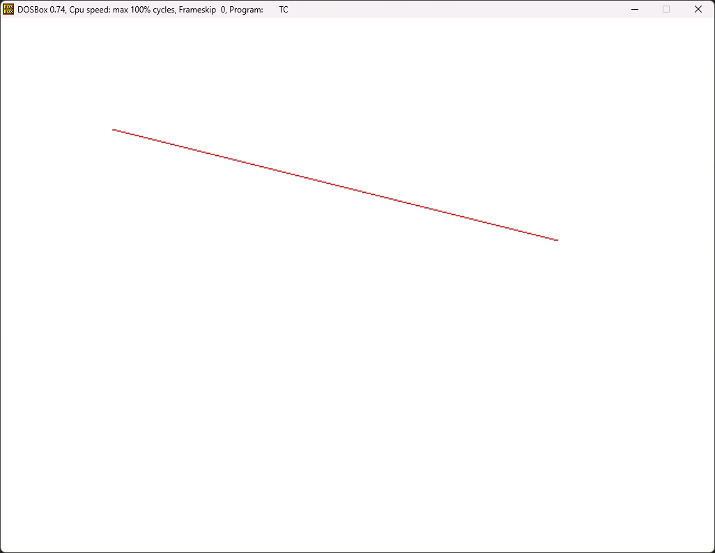

(Aditya Pandey)

**Q3. WAP to scan convert a line using Bresenham's Line Drawing Alogrithm.**

#include<stdio.h>   
#include<conio.h>   
#include<graphics.h>

void main() {   
 int gd = DETECT, gm;   
 float x, y, dx, dy, steps, d;   
 int x0, x1, y0, y1;   
 initgraph(&gd, &gm, "C:\\TC\\BGI");   
 setbkcolor(WHITE);   
 x0 = 50, y0 = 50, x1 = 500, y1 = 250;   
 dx = (float)(x1-x0);   
 dy = (float)(y1-y0);   
 x = x0;   
 y = y0;   
 d = 2*dy - dx;   
 while(x < x1) {   
 if(d >= 0) {   
 putpixel(x, y, 7);   
 y = y + 1;   
 d = d + 2*dy - 2*dx;   
 } else {   
 putpixel(x, y, RED);   
 d = d + 2*dy;   
 }   
 x += 1;   
 }   
 getch();   
 closegraph();   
}

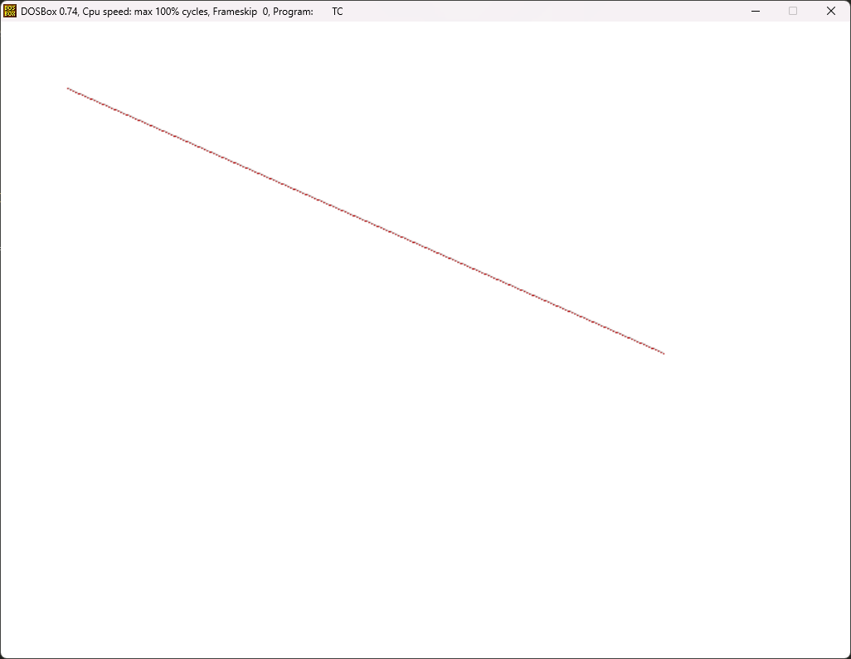

(Aditya Pandey)

**Q4. WAP to scan convert a circle using Bresenham's Circle Drawing Algorithm.**

#include<stdio.h>   
#include<conio.h>   
#include<graphics.h>

void main() {   
 int gd = DETECT, gm;   
 int x0=100, y0=100, r=50;   
 int x = 0;   
 int y = r;   
 int d = 3 - 2 * r;   
 initgraph(&gd, &gm, "C:\\TC\\BGI");   
 setbkcolor(WHITE);   
 while (x <= y) {   
 putpixel(x0 + x, y0 + y, RED);   
 putpixel(x0 - x, y0 + y, RED);   
 putpixel(x0 + x, y0 - y, RED);   
 putpixel(x0 - x, y0 - y, RED);   
 putpixel(x0 + y, y0 + x, RED);   
 putpixel(x0 - y, y0 + x, RED);   
 putpixel(x0 + y, y0 - x, RED);   
 putpixel(x0 - y, y0 - x, RED);   
 if (d < 0) {   
 d += 4*x + 6;   
 } else {   
 d += 4*(x-y) + 10;   
 y -= 1;   
 }   
 x++;   
 }   
 getch();   
 closegraph();   
}

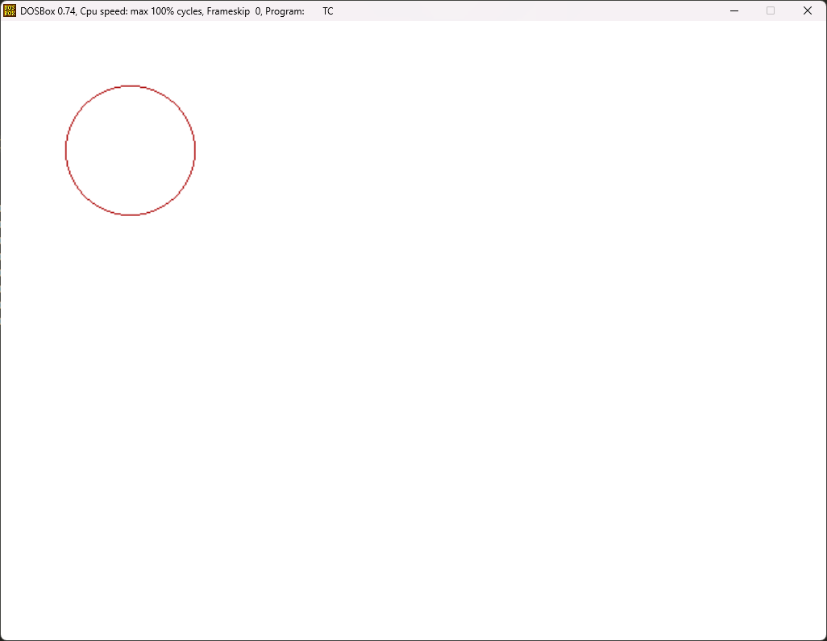

(Aditya Pandey)

**Aditya Pandey (04814002021)  
BCA 3rd Year 1st Shift  
Computer Graphics (BCA 373)  
Practical Assignment 2**

**Q1. WAP to draw Flying Balloon.**

#include<stdio.h>  
#include<conio.h>  
#include<graphics.h>

void main() {  
 int i, j;  
 int gd = DETECT, gm;  
 initgraph(&gd, &gm, "C:\\TC\\BGI");  
 setbkcolor(15);  
 j=getmaxy()/2;  
 for(i=0; i<100; i+=1) {  
 cleardevice();  
 setcolor(RED);  
 ellipse(getmaxx()/2-100, j, 0, 360, 30, 50);  
 line(getmaxx()/2-100, j+50, getmaxx()/2-100, j+80);  
 ellipse(getmaxx()/2, j+50, 0, 360, 30, 50);  
 line(getmaxx()/2, j+100, getmaxx()/2, j+130);  
 ellipse(getmaxx()/2+100, j, 0, 360, 30, 50);  
 line(getmaxx()/2+100, j+50, getmaxx()/2+100, j+80);  
 j-=1;  
 delay(10);  
 }  
 getch();  
 closegraph();  
}

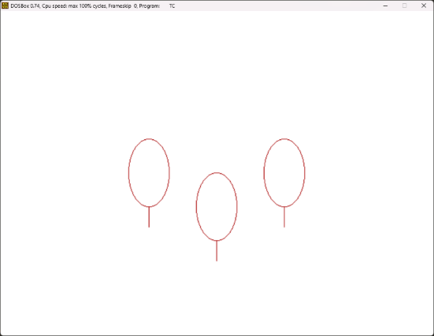 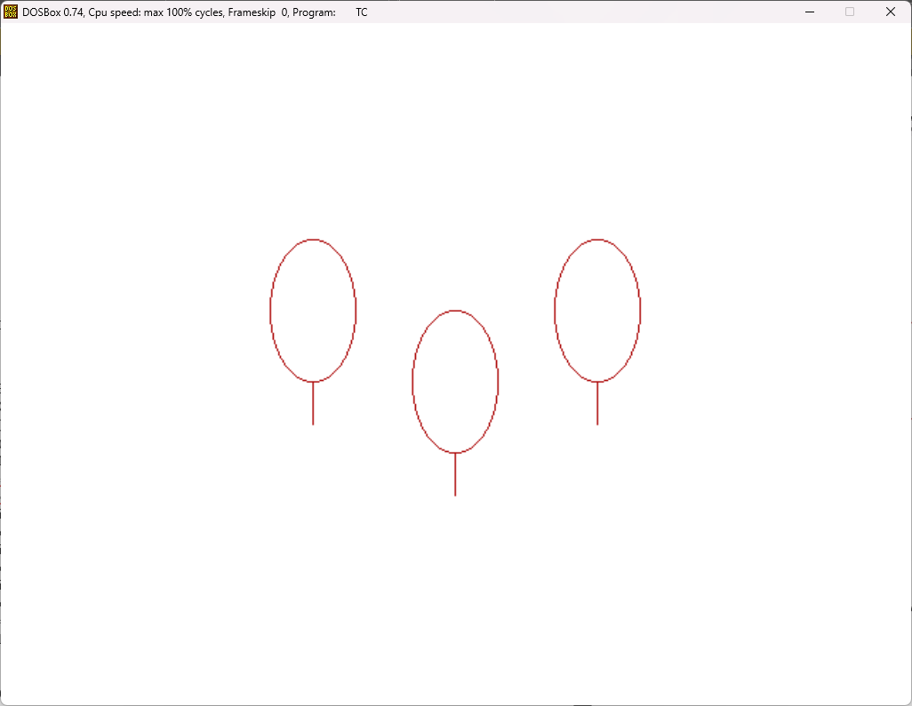

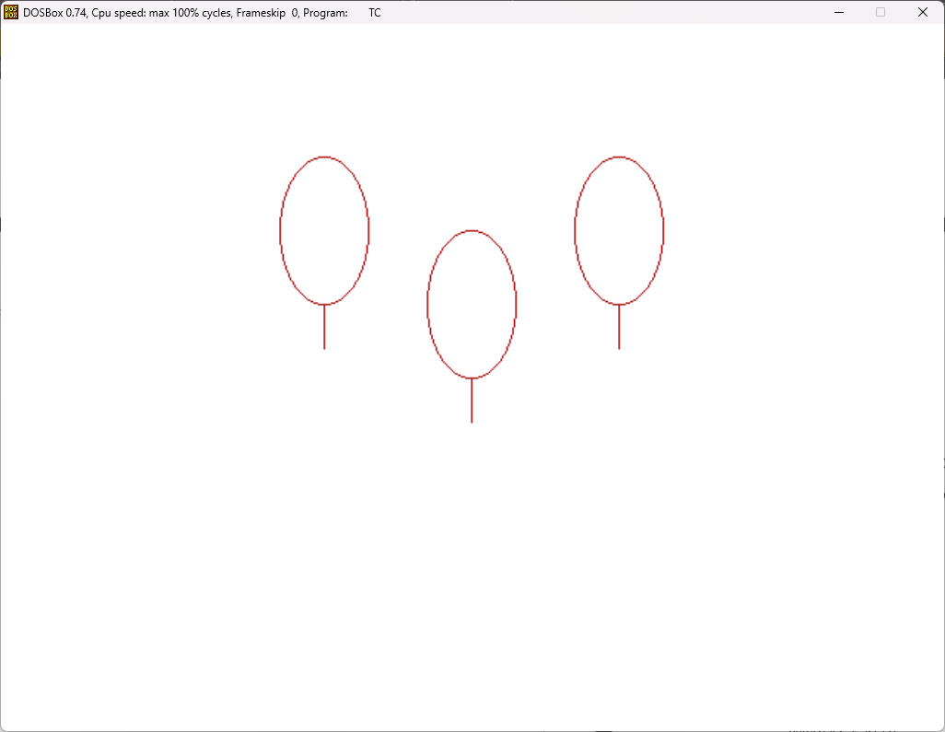

**Q2. WAP to move a vehicle (car) from left to right.**

#include<stdio.h>  
#include<conio.h>  
#include<graphics.h>

void main() {  
 int i, j;  
 int gd = DETECT, gm;  
 initgraph(&gd, &gm, "C:\\TC\\BGI");  
 setbkcolor(15);  
 j=20;  
 for(i=0; i<100; i+=1) {  
 cleardevice();  
 setcolor(RED);  
 line(j, 250, j+20, 250);  
 ellipse(j+50, 250, 0, 180, 30, 30);  
 circle(j+50, 250, 20);  
 line(j+80, 250, j+100, 250);  
 ellipse(j+130, 250, 0, 180, 30, 30);  
 circle(j+130, 250, 20);  
 line(j+160, 250, j+180, 250);  
 line(j, 250, j+20, 200);  
 line(j+20, 200, j+160, 200);  
 line(j+160, 200, j+180, 250);  
 ellipse(j+90, 200, 0, 180, 40, 40);  
 j+=4;  
 delay(10);  
 }  
 getch();  
 closegraph();  
}

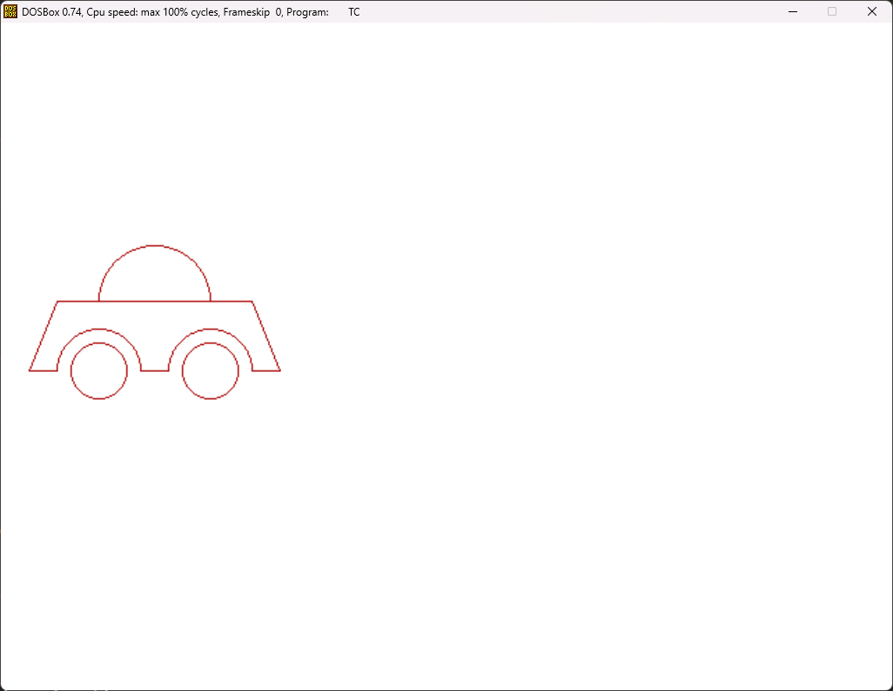

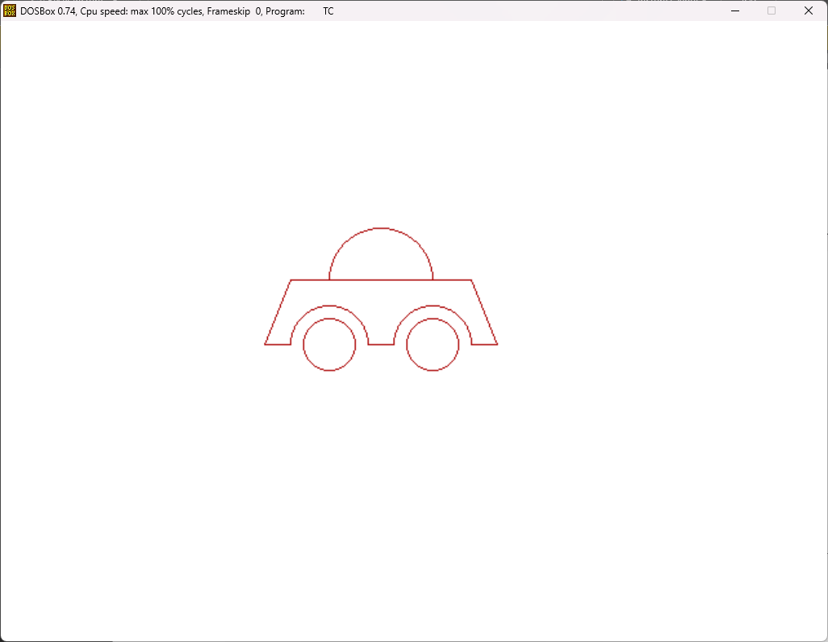

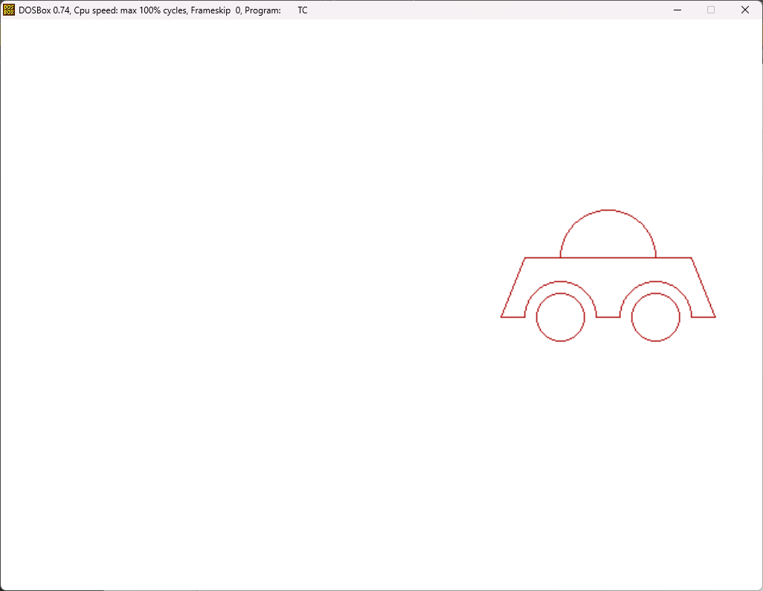

**Q3. WAP to clip a line segment using Cohen-Sutherland algorithm.**

#include<graphics.h>  
#include<conio.h>  
#include<stdio.h>  
int codeEntry[4] = {0,0,0,0}, codeExit[4] = {0,0,0,0}, codeOper[4] = {0,0,0,0}, codeOperFlag=0, i;  
float slope;  
int XMin, YMin, XMax, YMax, x1, y1, x2, y2;  
void codeLine(int calcCode[4], float x, float y, float XMin, float YMin, float XMax, float YMax) {  
 if(x < XMin) {  
 calcCode[3] = 1; // Left  
 } if(x > XMax) {  
 calcCode[2] = 1; // Right  
 } if(y > YMax) {  
 calcCode[1] = 1; // Bottom  
 } if(y < YMin) {  
 calcCode[0] = 1; // Top  
 }  
}

void main() {  
 int gd=DETECT, gm;  
 initgraph(&gd, &gm, "C:\\TC\\BGI");  
 setbkcolor(WHITE);  
 printf("\n *********** Cohen Sutherland Line Clipping Algorithm *********** \n");  
 printf("Enter XMin: ");  
 scanf("%d", &XMin);  
 printf("Enter YMin: ");  
 scanf("%d", &YMin);  
 printf("Enter XMax: ");  
 scanf("%d", &XMax);  
 printf("Enter YMax: ");  
 scanf("%d", &YMax);  
 printf("Enter intial point x1: ");  
 scanf("%d",&x1);  
 printf("Enter intial point y1: ");  
 scanf("%d",&y1);  
 printf("Enter final point x2: ");  
 scanf("%d",&x2);  
 printf("Enter final point y2: ");  
 scanf("%d",&y2);  
 delay(1000);  
 cleardevice();   
 setcolor(BLACK);  
 rectangle(XMin, YMin, XMax, YMax);  
 line(x1, y1, x2, y2);  
 codeLine(codeEntry, x1, y1, XMin, YMin, XMax, YMax);  
 codeLine(codeExit, x2, y2, XMin, YMin, XMax, YMax);  
 codeOperFlag = 1;  
 for(i=0 ; i<4 ; i++) {  
 codeOper[i] = codeEntry[i] || codeExit[i];  
 if(codeOper[i] == 1) { codeOperFlag = 0; }  
 }  
  
 if(codeOperFlag == 1) { printf("Case fully visible."); }  
 else {  
 codeOperFlag = 1;  
 for(i=0 ; i<4 ; i++) {  
 codeOper[i] = codeEntry[i] && codeExit[i];  
 if(codeOper[i] == 1) { codeOperFlag = 0; }  
 }  
 if(codeOperFlag == 0) { printf("Case fully invisible."); }  
 else {  
 slope = (float)(y2-y1)/(x2-x1);  
 if(codeEntry[3] == 1 && (x1<XMin || x1>XMax)) {  
 y1 += (XMin-x1)*slope;  
 x1 = XMin;  
 } if(codeEntry[2] == 1 && (x1<XMin || x1>XMax)) {  
 y1 += (XMax-x1)*slope;  
 x1 = XMax;  
 } if(codeEntry[1] == 1 && (y1<YMin || y1>YMax)) {  
 x1 += (YMax-y1)/slope;  
 y1 = YMax;  
 } if(codeEntry[0] == 1 && (y1<YMin || y1>YMax)) {  
 x1 += (YMin-y1)/slope;  
 y1 = YMin;  
 }  
 if(codeExit[3] == 1 && (x2<XMin || x2>XMax)) {  
 y2 += (XMin-x2)*slope;  
 x2 = XMin;  
 } if(codeExit[2] == 1 && (x2<XMin || x2>XMax)) {  
 y2 += (XMax-x2)*slope;  
 x2 = XMax;  
 } if(codeExit[1] == 1 && (y2<YMin || y2>YMax)) {  
 x2 += (YMax-y2)/slope;  
 y2 = YMax;  
 } if(codeExit[0] == 1 && (y2<YMin || y2>YMax)) {  
 x2 += (YMin-y2)/slope;  
 y2 = YMin;  
 }  
 delay(3000);  
 clearviewport();  
 rectangle(XMin, YMin, XMax, YMax);  
 setcolor(RED);  
 line(x1, y1, x2, y2);  
 }  
 }  
 getch();  
 closegraph();  
}

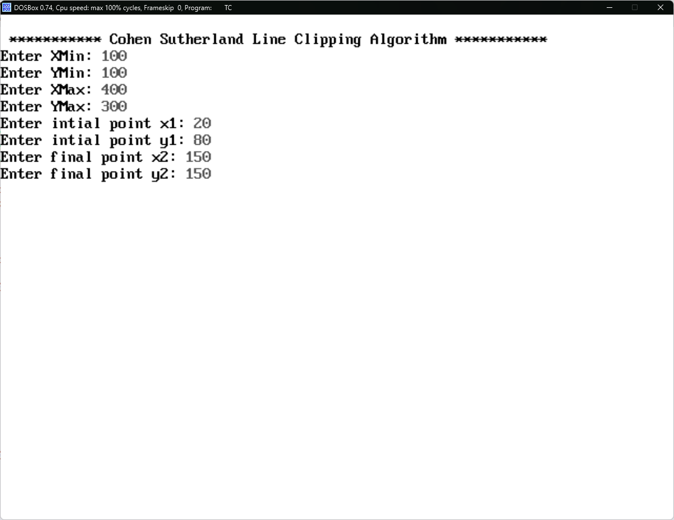

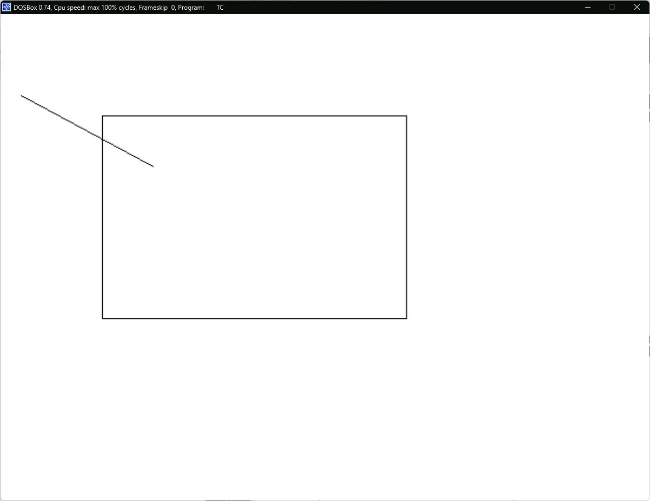

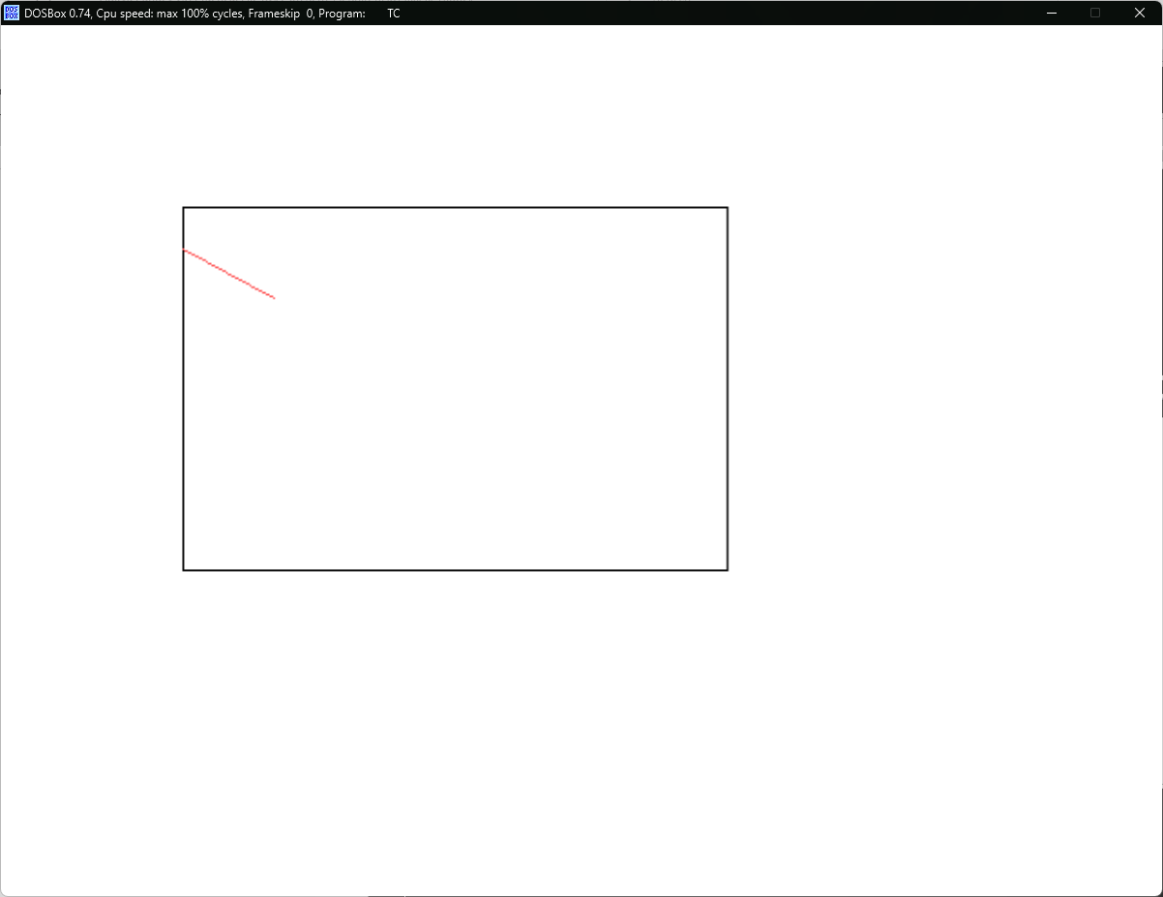

**Aditya Pandey (04814002021)  
BCA 3rd Year 1st Shift  
Computer Graphics (BCA 373)  
Practical Assignment 3**

**Q1. WAP to translate a triangle in 2D plane.**

#include<stdio.h>

#include<conio.h>

#include<graphics.h>

void main() {

int x1=200, y1=100, x2=100, y2=300, x3=300, y3=300, dx=-20, dy=-25;

int gd = DETECT, gm;

initgraph(&gd, &gm, "C:\\TC\\BGI");

setbkcolor(WHITE);

setcolor(BLUE);

line(x1, y1, x2, y2);

line(x2, y2, x3, y3);

line(x3, y3, x1, y1);

delay(1000);

x1 += dx;

y1 += dy;

x2 += dx;

y2 += dy;

x3 += dx;

y3 += dy;

cleardevice();

setcolor(RED);

line(x1, y1, x2, y2);

line(x2, y2, x3, y3);

line(x3, y3, x1, y1);

getch();

closegraph();

}

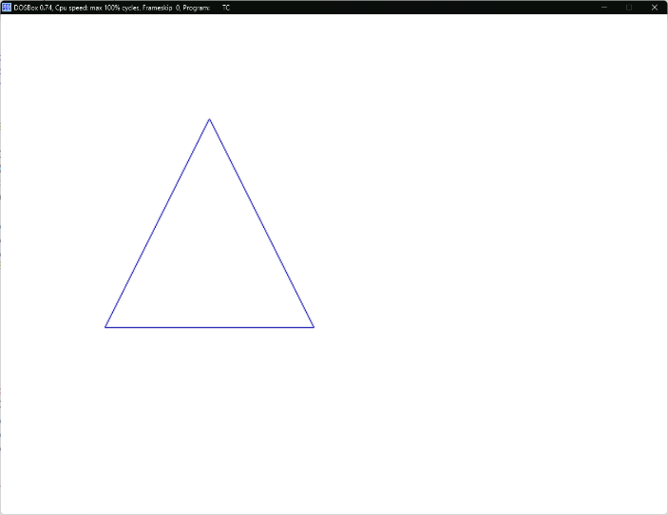 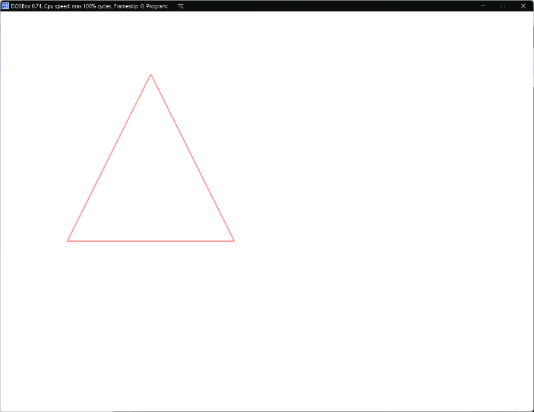

**Q2. WAP to rotate a triangle in 2D plane.**

#include<stdio.h>

#include<conio.h>

#include<graphics.h>

#include<math.h>

#define pi 3.14f

void main() {

int x1=40, y1=20, x2=20, y2=60, x3=60, y3=60, xc=0, yc=0;

float angle=60.0f, a1, b1, a2, b2, a3, b3;

int gd = DETECT, gm;

initgraph(&gd, &gm, "C:\\TC\\BGI");

setbkcolor(WHITE);

setcolor(BLUE);

line(getmaxx() / 2, 0, getmaxx() / 2, getmaxy());

line(0, getmaxy() / 2, getmaxx(), getmaxy() / 2);

setcolor(BLACK);

line(x1+getmaxx()/2, y1+getmaxy()/2, x2+getmaxx()/2, y2+getmaxy()/2);

line(x2+getmaxx()/2, y2+getmaxy()/2, x3+getmaxx()/2, y3+getmaxy()/2);

line(x3+getmaxx()/2, y3+getmaxy()/2, x1+getmaxx()/2, y1+getmaxy()/2);

printf("Enter the coordinates of Pivot: ");

scanf("%d %d", &xc, &yc);

printf("Enter the angle of rotation: ");

scanf("%f", &angle);

delay(1000);

x1 -= xc; y1 -= yc;

x2 -= xc; y2 -= yc;

x3 -= xc; y3 -= yc;

angle *= (pi/180.0f);

a1 = x1*cos(angle) - y1*sin(angle);

b1 = x1*sin(angle) + y1*cos(angle);

a2 = x2*cos(angle) - y2*sin(angle);

b2 = x2*sin(angle) + y2*cos(angle);

a3 = x3*cos(angle) - y3*sin(angle);

b3 = x3*sin(angle) + y3*cos(angle);

a1 += xc; b1 += yc;

a2 += xc; b2 += yc;

a3 += xc; b3 += yc;

cleardevice();

setcolor(BLUE);

line(getmaxx() / 2, 0, getmaxx() / 2, getmaxy());

line(0, getmaxy() / 2, getmaxx(), getmaxy() / 2);

setcolor(RED);

line(a1+getmaxx()/2, b1+getmaxy()/2, a2+getmaxx()/2, b2+getmaxy()/2);

line(a2+getmaxx()/2, b2+getmaxy()/2, a3+getmaxx()/2, b3+getmaxy()/2);

line(a3+getmaxx()/2, b3+getmaxy()/2, a1+getmaxx()/2, b1+getmaxy()/2);

getch();

closegraph();

}

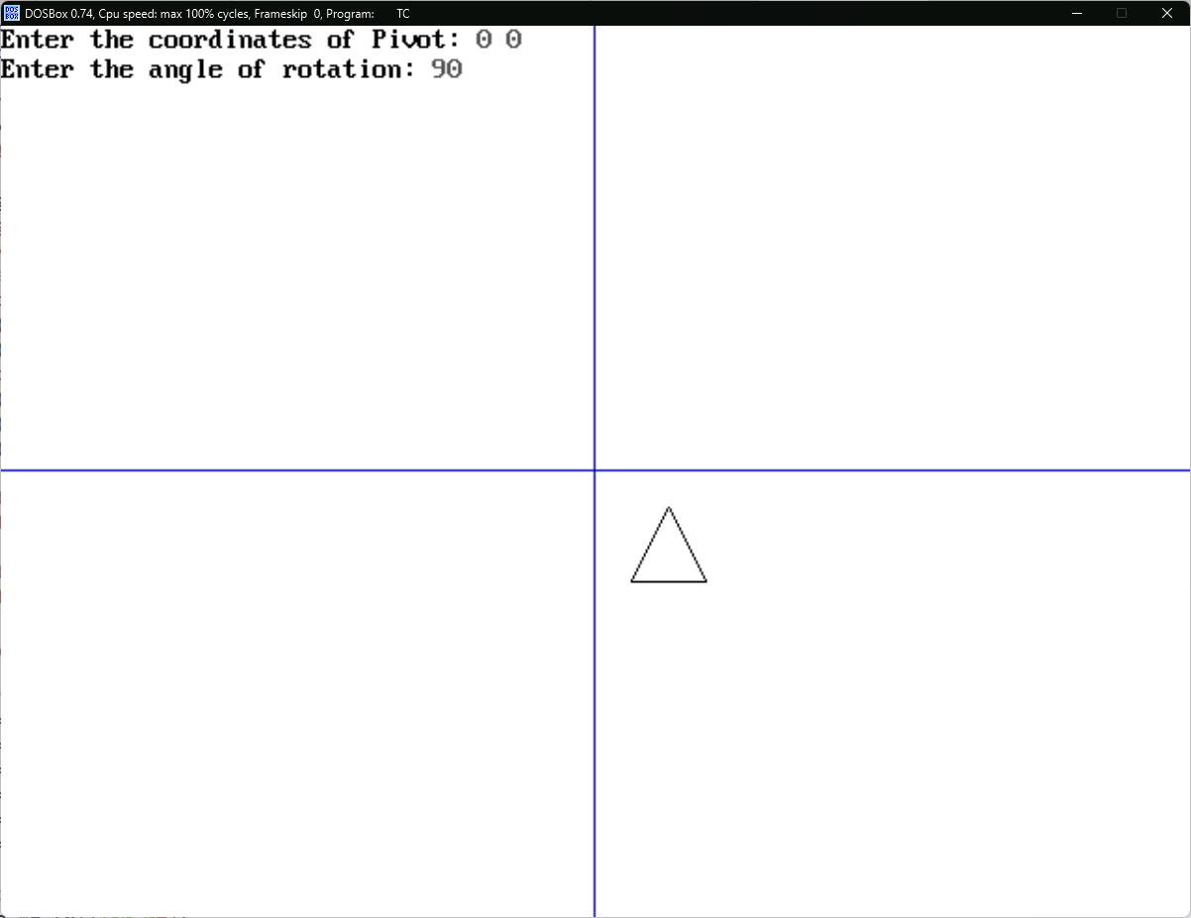

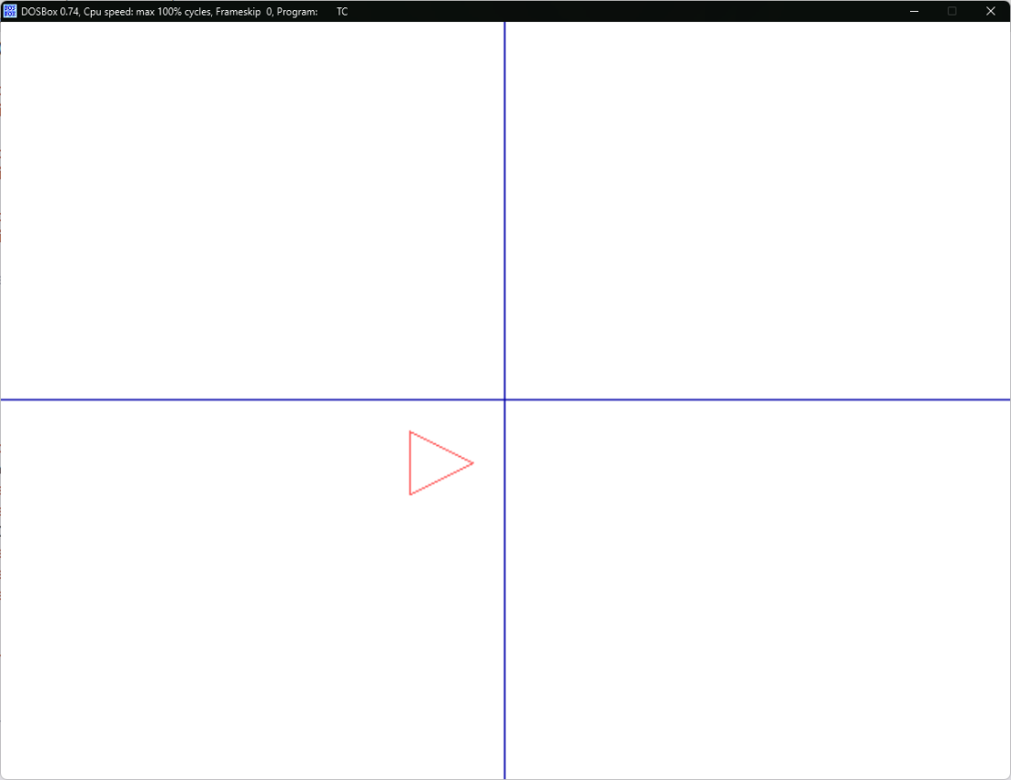

**Q3. Write a menu driven program to scale, reflect, and shear a triangle in a 2D plane.**

#include<stdio.h>

#include<conio.h>

#include<graphics.h>

void main() {

int x1=10, y1=10, x2=30, y2=10, x3=30, y3=30, dx=20, dy=30, axis, ch=0;

float sh=0.2;

int gd = DETECT, gm;

initgraph(&gd, &gm, "C:\\TC\\BGI");

setbkcolor(WHITE);

do {

delay(1000);

clrscr();

delay(250);

setcolor(BLUE);

line(getmaxx() / 2, 0, getmaxx() / 2, getmaxy());

line(0, getmaxy() / 2, getmaxx(), getmaxy() / 2);

setcolor(RED);

line(x1+getmaxx()/2, y1+getmaxy()/2, x2+getmaxx()/2, y2+getmaxy()/2);

line(x2+getmaxx()/2, y2+getmaxy()/2, x3+getmaxx()/2, y3+getmaxy()/2);

line(x3+getmaxx()/2, y3+getmaxy()/2, x1+getmaxx()/2, y1+getmaxy()/2);

printf("1. Scale\n2. Reflect\n3. Shear\nor Exit\nEnter your choice: ");

scanf("%d", &ch);

if(ch==1) {

printf("Enter scale :- sx, sy: ");

scanf("%d %d", &dx, &dy);

x1 *= dx; y1 *= dy;

x2 *= dx; y2 *= dy;

x3 *= dx; y3 *= dy;

} else if(ch==2) {

printf("1. x\n2. y\n3. xy\nWhich axis to reflect on: ");

scanf("%d", &axis);

if(axis==1) {

dx = 1; dy = -1;

} else if(axis==2) {

dx = -1; dy = 1;

} else if(axis==3) {

dx = -1; dy = -1;

} else {

printf("Invalid choice");

continue;

}

x1 *= dx; y1 *= dy;

x2 *= dx; y2 *= dy;

x3 *= dx; y3 *= dy;

} else if(ch==3) {

printf("Enter shear factor: ");

scanf("%d", &sh);

printf("1. x\n2. y\nWhich axis to sheer on: ");

scanf("%d", &axis);

if(axis==1) {

x1 += y1*sh;

x2 += y2*sh;

x3 += y3*sh;

} else if(axis==2) {

y1 += x1*sh;

y2 += x2*sh;

y3 += x3*sh;

} else {

printf("Invalid choice");

continue;

}

} else {

break;

}

} while(ch);

closegraph();

}

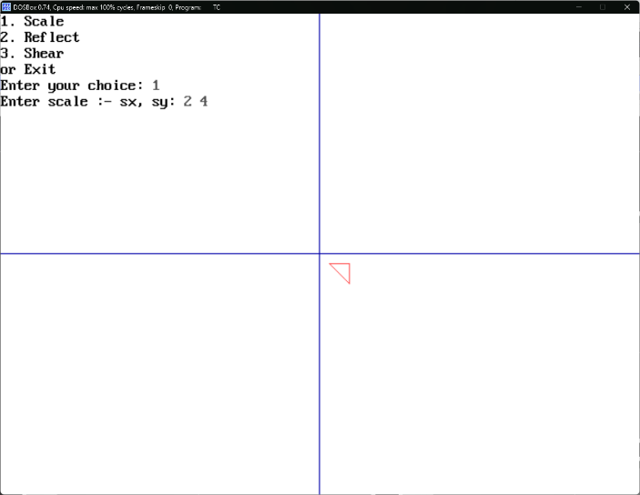 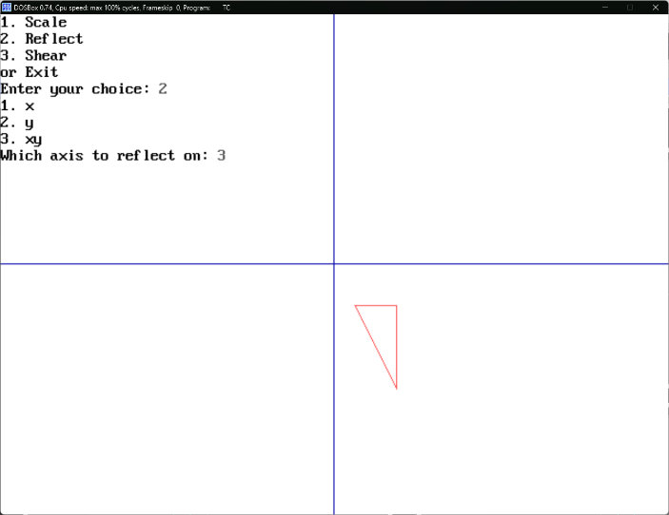

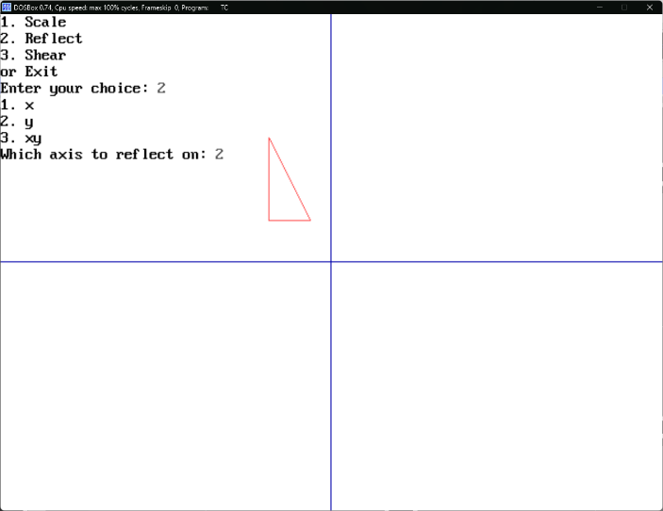 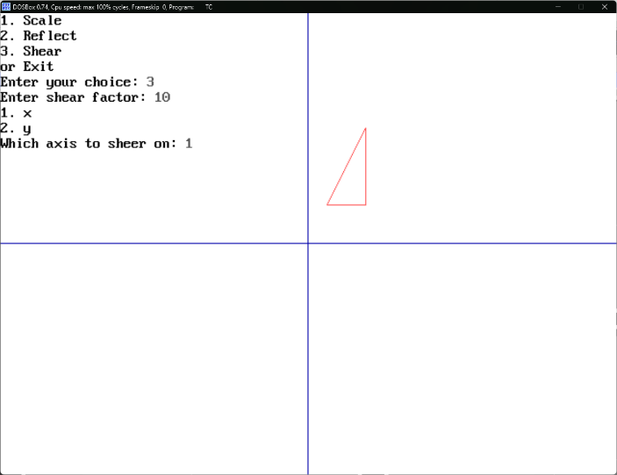

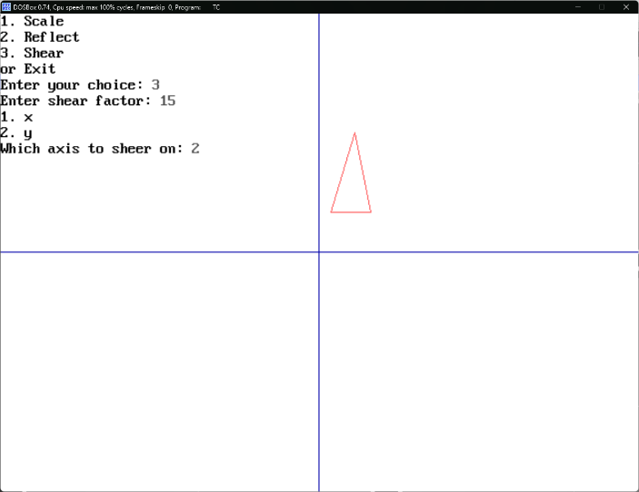 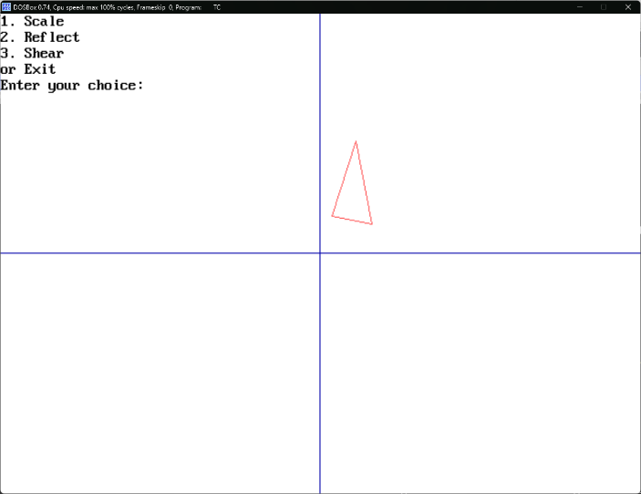

**Q4. WAP to make an analog clock.**

#include<stdio.h>

#include<conio.h>

#include<graphics.h>

#include<math.h>

#define pi 3.14f

float xSec=0.0f, ySec=-70.0f, xMin=0.0f, yMin=-60.0f, xHr=0.0f, yHr=-50.0f;

float a, b;

float angleSec=0.0f, angleMin=0.0f, angleHr=0.0f;

void layout() {

circle(getmaxx()/2, getmaxy()/2, 100);

circle(getmaxx()/2, getmaxy()/2, 80);

outtextxy(getmaxx()/2-7, getmaxy()/2-75, "12");

outtextxy(getmaxx()/2+35, getmaxy()/2-65, "1");

outtextxy(getmaxx()/2+57, getmaxy()/2-38, "2");

outtextxy(getmaxx()/2+70, getmaxy()/2-3, "3");

outtextxy(getmaxx()/2+60, getmaxy()/2+32, "4");

outtextxy(getmaxx()/2+35, getmaxy()/2+58, "5");

outtextxy(getmaxx()/2-2, getmaxy()/2+70, "6");

outtextxy(getmaxx()/2-41, getmaxy()/2+60, "7");

outtextxy(getmaxx()/2-67, getmaxy()/2+32, "8");

outtextxy(getmaxx()/2-75, getmaxy()/2-3, "9");

outtextxy(getmaxx()/2-67, getmaxy()/2-35, "10");

outtextxy(getmaxx()/2-44, getmaxy()/2-62, "11");

circle(getmaxx()/2, getmaxy()/2, 5);

}

void hands(float x, float y, float angle, char col) {

a = x*cos(angle) - y*sin(angle);

b = x*sin(angle) + y*cos(angle);

setcolor(WHITE);

layout();

if(col=='S')

setcolor(GREEN);

else if(col=='M')

setcolor(RED);

else if(col=='H')

setcolor(BLUE);

line(getmaxx()/2, getmaxy()/2, a+getmaxx()/2, b+getmaxy()/2);

}

void main() {

int i, j;

int gd = DETECT, gm;

initgraph(&gd, &gm, "C:\\TC\\BGI");

setbkcolor(WHITE);

layout();

while(1) {

for(j=0 ; j<60 ; j++) {

for(i=0 ; i<60 ; i++) {

cleardevice();

hands(xSec, ySec, angleSec, 'S');

angleSec += (pi/30.0f);

if(angleSec >= pi*2.0f) {

angleSec -= pi*2.0f;

}

hands(xMin, yMin, angleMin, 'M');

hands(xHr, yHr, angleHr, 'H');

delay(1000);

}

angleMin += (pi/30.0f);

if(angleMin >= pi*2.0f) {

angleMin -= pi*2.0f;

}

}

angleHr += (pi/30.0f);

if(angleHr >= pi*2.0f) {

angleHr -= pi*2.0f;

}

}

getch();

closegraph();

}

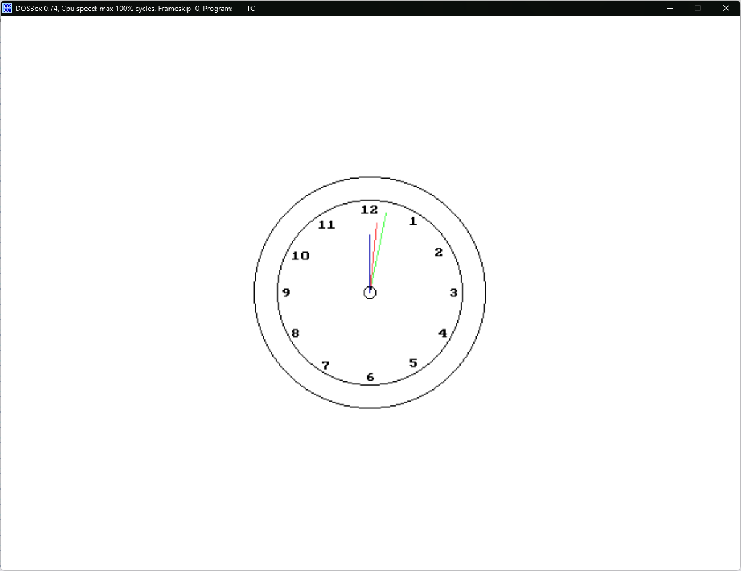

**Q5. WAP to make a moving fan.**

#include<stdio.h>

#include<conio.h>

#include<graphics.h>

#include<math.h>

#define pi 3.14

float xa1=0.0f, xa2=-25.0f, xa3=25.0f, xb1=25.0f, xb2=100.0f, xb3=100.0f, xc1=0.0f, xc2=25.0f, xc3=-25.0f, xd1=-25.0f, xd2=-100.0f, xd3=-100.0f;

float ya1=-25.0f, ya2=-100.0f, ya3=-100.0f, yb1=0.0f, yb2=-25.0f, yb3=25.0f, yc1=25.0f, yc2=100.0f, yc3=100.0f, yd1=0.0f, yd2=25.0f, yd3=-25.0f;

float angle=0.0f, a1, b1, a2, b2, a3, b3;

void fans(float x1, float y1, float x2, float y2, float x3, float y3) {

setcolor(BLACK);

line(x1, y1, x2, y2);

line(x2, y2, x3, y3);

line(x3, y3, x1, y1);

}

void rotate(float x1, float y1, float x2, float y2, float x3, float y3, float angle) {

a1 = x1*cos(angle) - y1*sin(angle); b1 = x1*sin(angle) + y1*cos(angle);

a2 = x2*cos(angle) - y2*sin(angle); b2 = x2*sin(angle) + y2*cos(angle);

a3 = x3*cos(angle) - y3*sin(angle); b3 = x3*sin(angle) + y3*cos(angle);

x1 = a1; y1 = b1;

x2 = a2; y2 = b2;

x3 = a3; y3 = b3;

fans(a1+getmaxx()/2, b1+getmaxy()/2, a2+getmaxx()/2, b2+getmaxy()/2, a3+getmaxx()/2, b3+getmaxy()/2);

}

void main() {

int i=0;

int gd=DETECT, gm;

initgraph(&gd, &gm, "C:\\TC\\BGI");

setbkcolor(WHITE);

while(1) {

delay(10);

cleardevice();

rotate(xa1, ya1, xa2, ya2, xa3, ya3, angle);

rotate(xb1, yb1, xb2, yb2, xb3, yb3, angle);

rotate(xc1, yc1, xc2, yc2, xc3, yc3, angle);

rotate(xd1, yd1, xd2, yd2, xd3, yd3, angle);

angle += (pi/30.0f);

circle(getmaxx()/2, getmaxy()/2, 25);

}

getch();

closegraph();

}

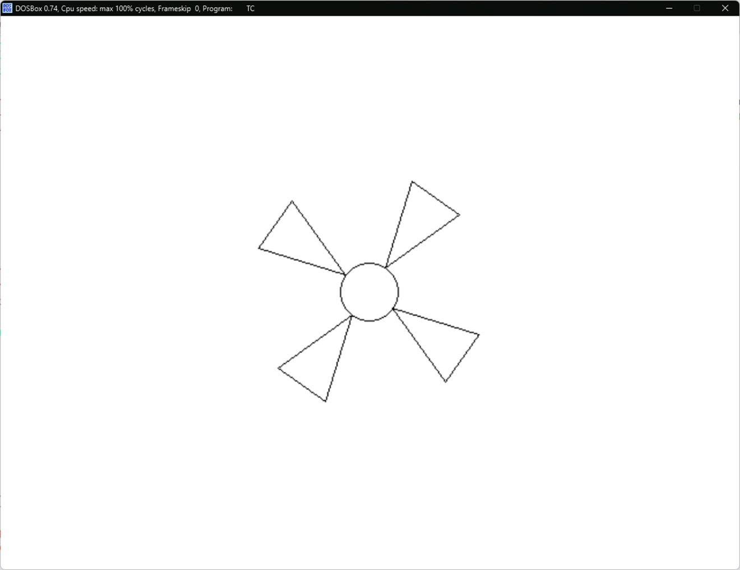

**Q6. WAP to draw a pie chart of family income and expenditure.**

#include<stdio.h>

#include<conio.h>

#include<graphics.h>

#include<math.h>

#define pi 3.14

float income, expd=0.0f, a, b;

void pieLine(float Per) {

Per *= pi/50.0f;

a = 100*sin(Per);

b = -100*cos(Per);

line(getmaxx()/2, getmaxy()/2, a + getmaxx()/2, b + getmaxy()/2);

}

void main() {

float food, cloth, house, travel, save;

int gd=DETECT, gm;

initgraph(&gd, &gm, "C:\\TC\\BGI");

setbkcolor(WHITE);

setcolor(BLACK);

printf("How much do you spend on food: ");

scanf("%f", &food);

printf("How much do you spend on cloth: ");

scanf("%f", &cloth);

printf("How much do you spend on house rent: ");

scanf("%f", &house);

printf("How much do you spend on travel: ");

scanf("%f", &travel);

printf("How much do you save: ");

scanf("%f", &save);

income = food + cloth + house + travel + save;

food = (food*100.0f)/income;

cloth = (cloth*100.0f)/income;

house = (house*100.0f)/income;

travel = (travel*100.0f)/income;

save = (save*100.0f)/income;

circle(getmaxx()/2, getmaxy()/2, 100);

expd += food; pieLine(expd);

expd += cloth; pieLine(expd);

expd += house; pieLine(expd);

expd += travel; pieLine(expd);

expd += save; pieLine(expd);

outtextxy(getmaxx()/2 - 110, getmaxy()/2 - 125, "INCOME-EXPENDITURE PIE-CHART");

getch();

closegraph();

}

